KAMAL GARG

B64527

B9

Q1

#include <stdio.h>

#include <stdlib.h>

int main()

{

    FILE *a, *b;

    char name[20], c;

    printf("Enter the filename to open for reading \n");

    scanf("%s", name);

    a = fopen("file1.txt", "r+");

    if (a == NULL)

    {

        printf("Cannot open file %s \n", name);

        exit(0);

    }

    printf("Enter the filename to open for writing \n");

    scanf("%s", name);

    b = fopen("file2.txt", "w+");

    if (b == NULL)

    {

        printf("Cannot open file %s \n", name);

        exit(0);

    }

    c = fgetc(a);

    while (c != EOF)

    {

        fputc(c, b);

        c = fgetc(a);

    }

    printf("\nContents copied to %s", name);

    fclose(a);

    fclose(b);

    return 0;

}

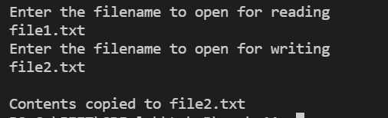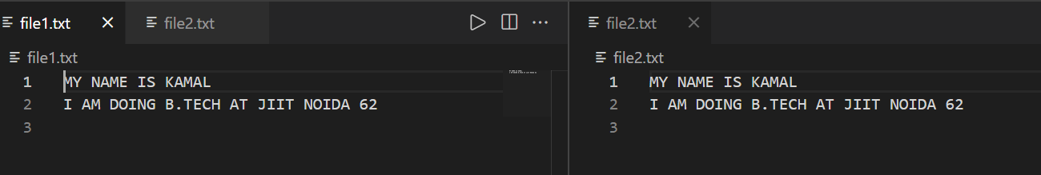

Q2

#include <stdio.h>

#include <stdlib.h>

int main()

{

    FILE *a, *b;

    char name[20], c;

    int x = 0, y = 0;

    printf("Enter the filenames to compare \n");

    scanf("%s", name);

    a = fopen("file1.txt", "r+");

    if (a == NULL)

    {

        printf("Cannot open file %s \n", name);

        exit(0);

    }

    scanf("%s", name);

    b = fopen("file2.txt", "r+");

    if (b == NULL)

    {

        printf("Cannot open file %s \n", name);

        exit(0);

    }

    c = fgetc(a);

    while (c != EOF)

    {

        y++;

        if (c != fgetc(b))

        {

            printf("\nFiles are same upto\nLine:%d\nColumn:%d", x + 1, y-1);

            break;

        }

        if (c == '\n')

        {

            x++;

            y = 0;

        }

        c = getc(a);

    }

    if (c == EOF)

    {

        printf("\nFiles are same");

    }

    fclose(a);

    fclose(b);

    return 0;

}

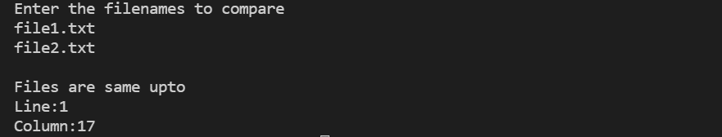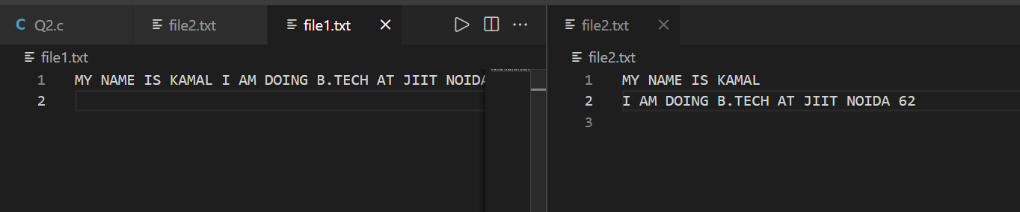

Q3

#include <stdio.h>

#include <stdlib.h>

int main()

{

    int n;

    char name[20];

    char branch[20];

    char enroll[20];

    FILE *fp;

    fp = fopen("record.txt", "a+");

    fseek(fp,0,SEEK_END);

    if (fp == NULL)

    {

        printf("Cannot open file /n");

        exit(0);

    }

    printf("how many students you want to enter:");

    scanf("%d", &n);

    printf("Enter in sequence--> name,branch,enroll\n");

    for (int i = 0; i < n; i++)

    {

        printf("student %d\n", i + 1);

        scanf("%s", name);

        scanf("%s", branch);

        scanf("%s", enroll);

        fprintf(fp,"%s,%s,%s\n", name, branch, enroll);

    }

    return 0;

}

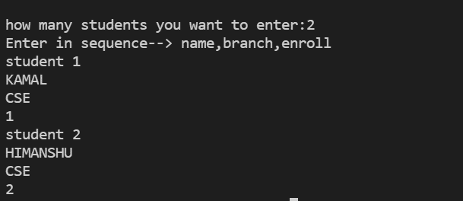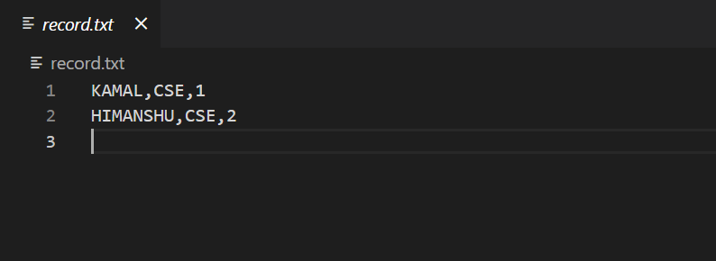

Q4

#include <stdio.h>

int main()

{

    FILE *f;

    int n, i, sum=0;

    f = fopen("int.txt", "a+");

    if (f == NULL)

    {

        perror("");

    }

    printf("How many integers to read:");

    scanf("%d", &n);

    for (int j = 0; j < n; j++)

    {

        fscanf(f, "%d ", &i);

        printf("%d\n", i);

        sum += i;

    }

    fprintf(f, "%d ", sum);

    printf("%d", sum);

    return 0;

}

